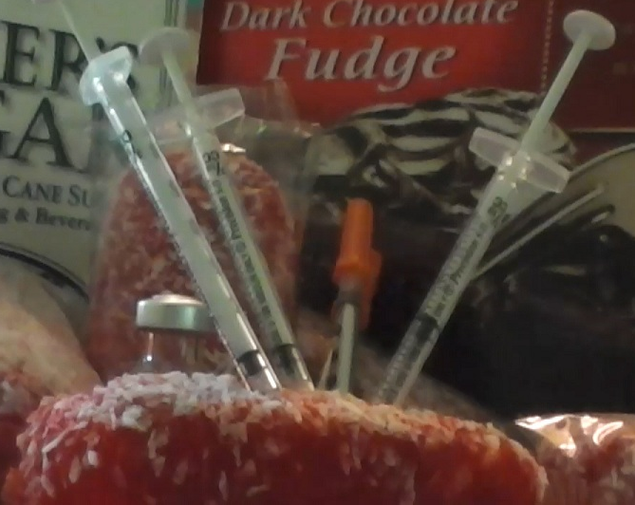

The Sweet Lowdown
Looking for actors, dancers, and crew for a play about diabetes.
Auditions will be held at the Wil-Mar Neighborhood Center (953 Jenifer St, Madison) on September 2, 3, 4, 2013, for a show running October 25 through November 16, 2013, at Broom Street Theater.
Written by Mary Fairweather Dexter and Matt DeFour; directed by Don Dexter and John Siewert. The Sweet Lowdown is made possible in part with funding from Diabetes Hands Foundation Seeds.
Interested? Email dondexter2000@yahoo.com
